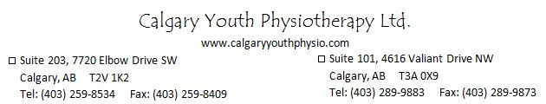

To register your child please complete the following form and return to Calgary Youth Physiotherapy South Office via fax (403-259-8409) or email (info@calgaryyouthphysio.com):

Camp Name (Please Check):
Summer Bike and Sport Camp – July 24-28 -$225.00 Age: 6-10____
Summer Bike and Sport Camp – Aug 14-18 -$225.00 Age: 6-10____

Child’s Name: _________________________

Consent:
I consent to my child’s participation in physical therapy summer camp sessions.
I understand there will not be reimbursement for illness or missed classes. If weather is poor on any given day a makeup class will be scheduled or families will be reimbursed for that particular day.
Payment in full is required prior to the commencement of the camps. Withdrawal of registration must occur 1 week prior to commencement of camp in order for full reimbursement. Any withdrawal less than 1 week prior to camp commencement will be subject to a 30% cancelation fee.

_______________________________________
(Parent/Guardian)
_____________________
(Date)

